**Machine Learning (Assignment # 4) Spring, 2023**

**Name:** Vineetha Gourishetty

**Student ID:** 700745899

**E-mail:** [VXG58990@ucmo.edu](mailto:VXG58990@ucmo.edu)

**Source Code:**

Source code for the assignment is provided in the link below:

<https://github.com/Vineetha-gourishetty/ML_Assignemnt4_700745899.git>

**Video Link of the logic explanation:**

Explanation for each question is recorded in the below video link:

<https://drive.google.com/file/d/1jrCe5wzwGIQhrfJ9Y1_s7uALHV_TnTtO/view?usp=sharing>

**Solution**

Please find the solution of given questions below:

**1. Pandas**

**1. Read the provided CSV file ‘data.csv’.** [**https://drive.google.com/drive/folders/1h8C3mLsso-R-sIOLsvoYwPLzy2fJ4IOF?usp=sharing**](https://drive.google.com/drive/folders/1h8C3mLsso-R-sIOLsvoYwPLzy2fJ4IOF?usp=sharing)

**Solution 1**:

I have initially importes drive from google.colab inorder to use the datasets from googgle drive and then used .mount for mounting the drive with googlecolab file.

.read_csv is in-built function used for importing csv file.

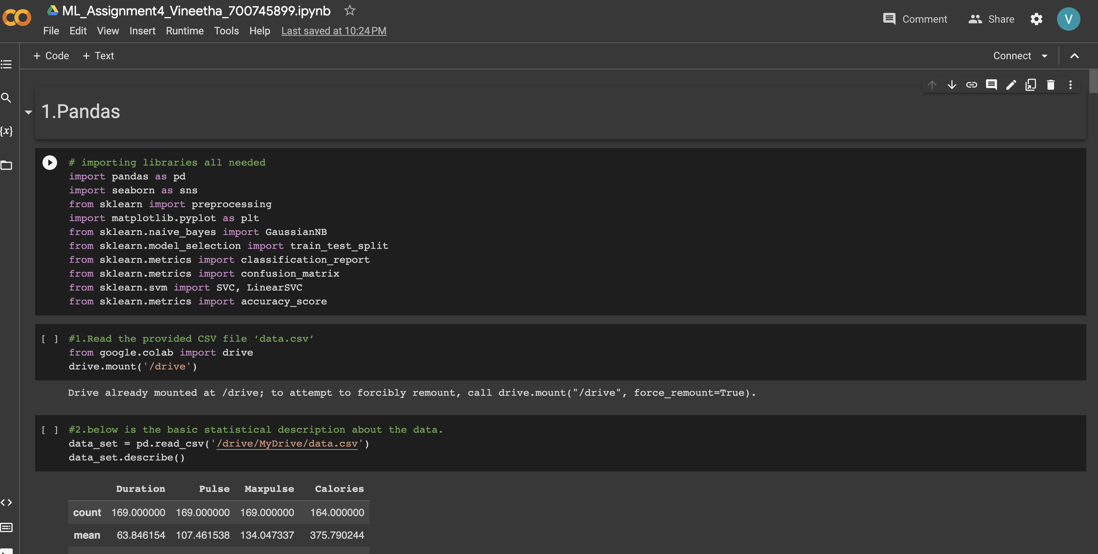

**2. Show the basic statistical description about the data.**

**Solution 2**:

describe() is the function used for showing basic statistical description.

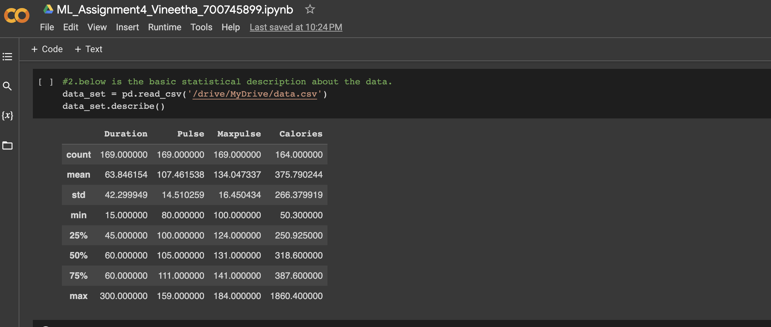

**3. Check if the data has null values.**

**a. Replace the null values with the mean**

**Solution 3**:

Dataframe.isnull().any() gives all the columns information in given dataset and True/False information for null values presence.

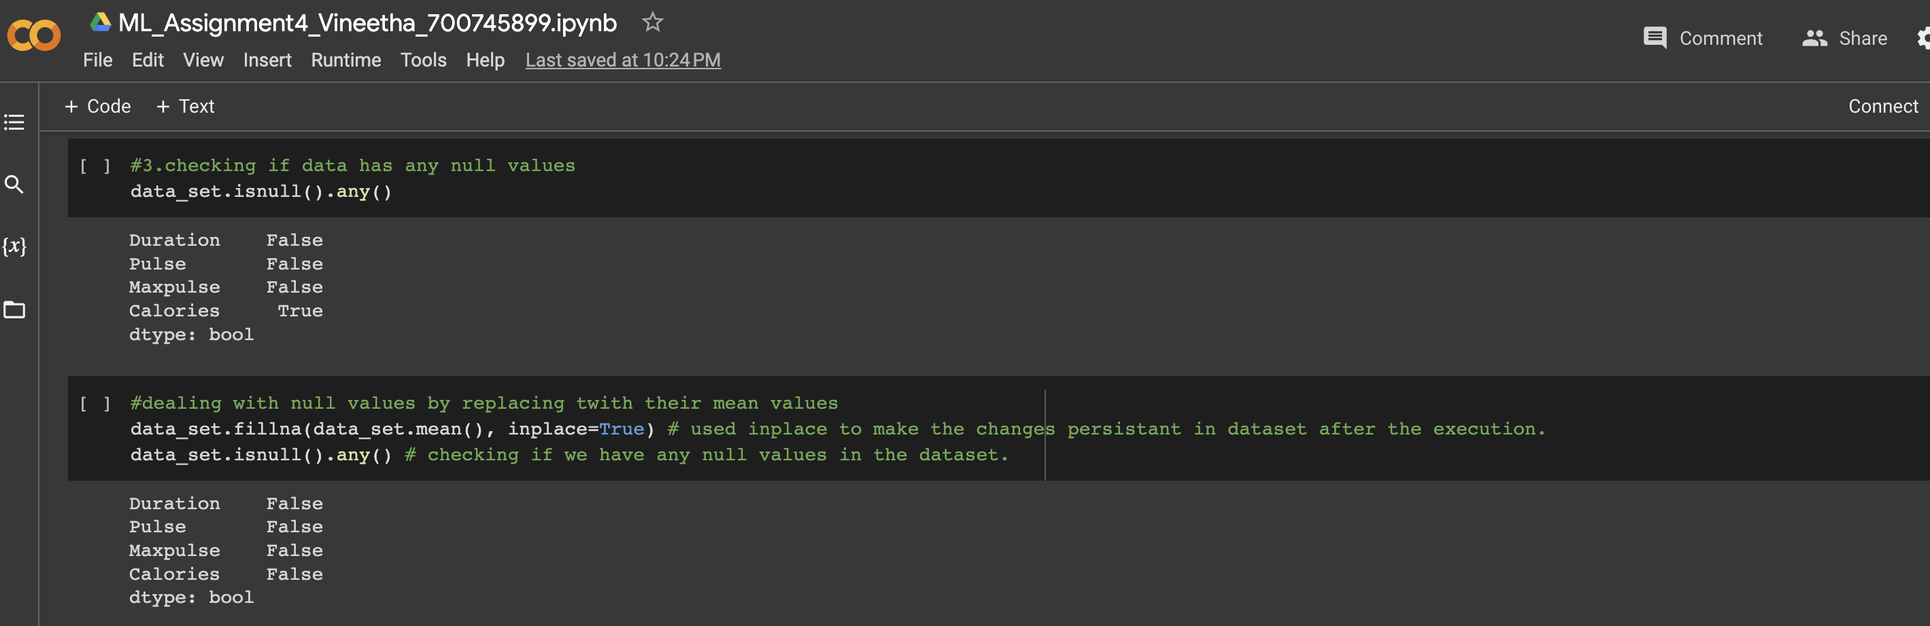

**4. Select at least two columns and aggregate the data using: min, max, count, mean.**

**Solution 4**:

I have used .agg() aggregate function to combine the data from two different columns (Pulse and Calories) and specified the required min, max, count, mean for each column name.

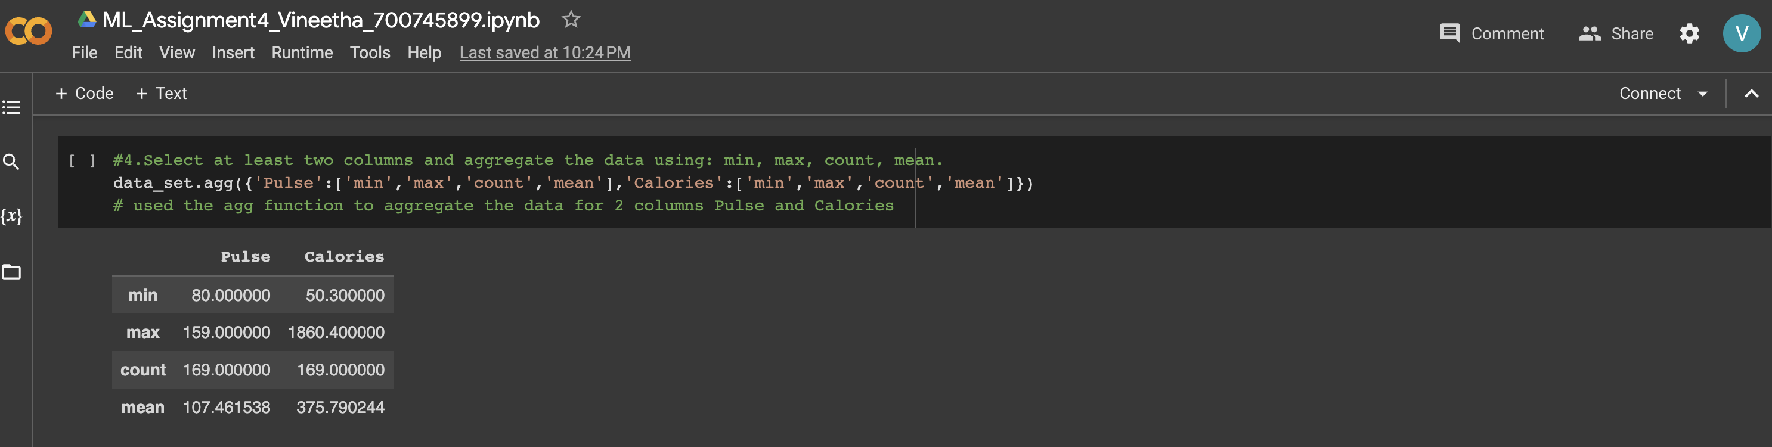

**5. Filter the dataframe to select the rows with calories values between 500 and 1000.**

**Solution 5**:

.loc function is used to display the required columns and rows from a dataframe also we could specify any conditional wise arguments as per the requirements.

Here, parameters are passed where it satifies calories values between 500 and 1000 as shown in below picture.

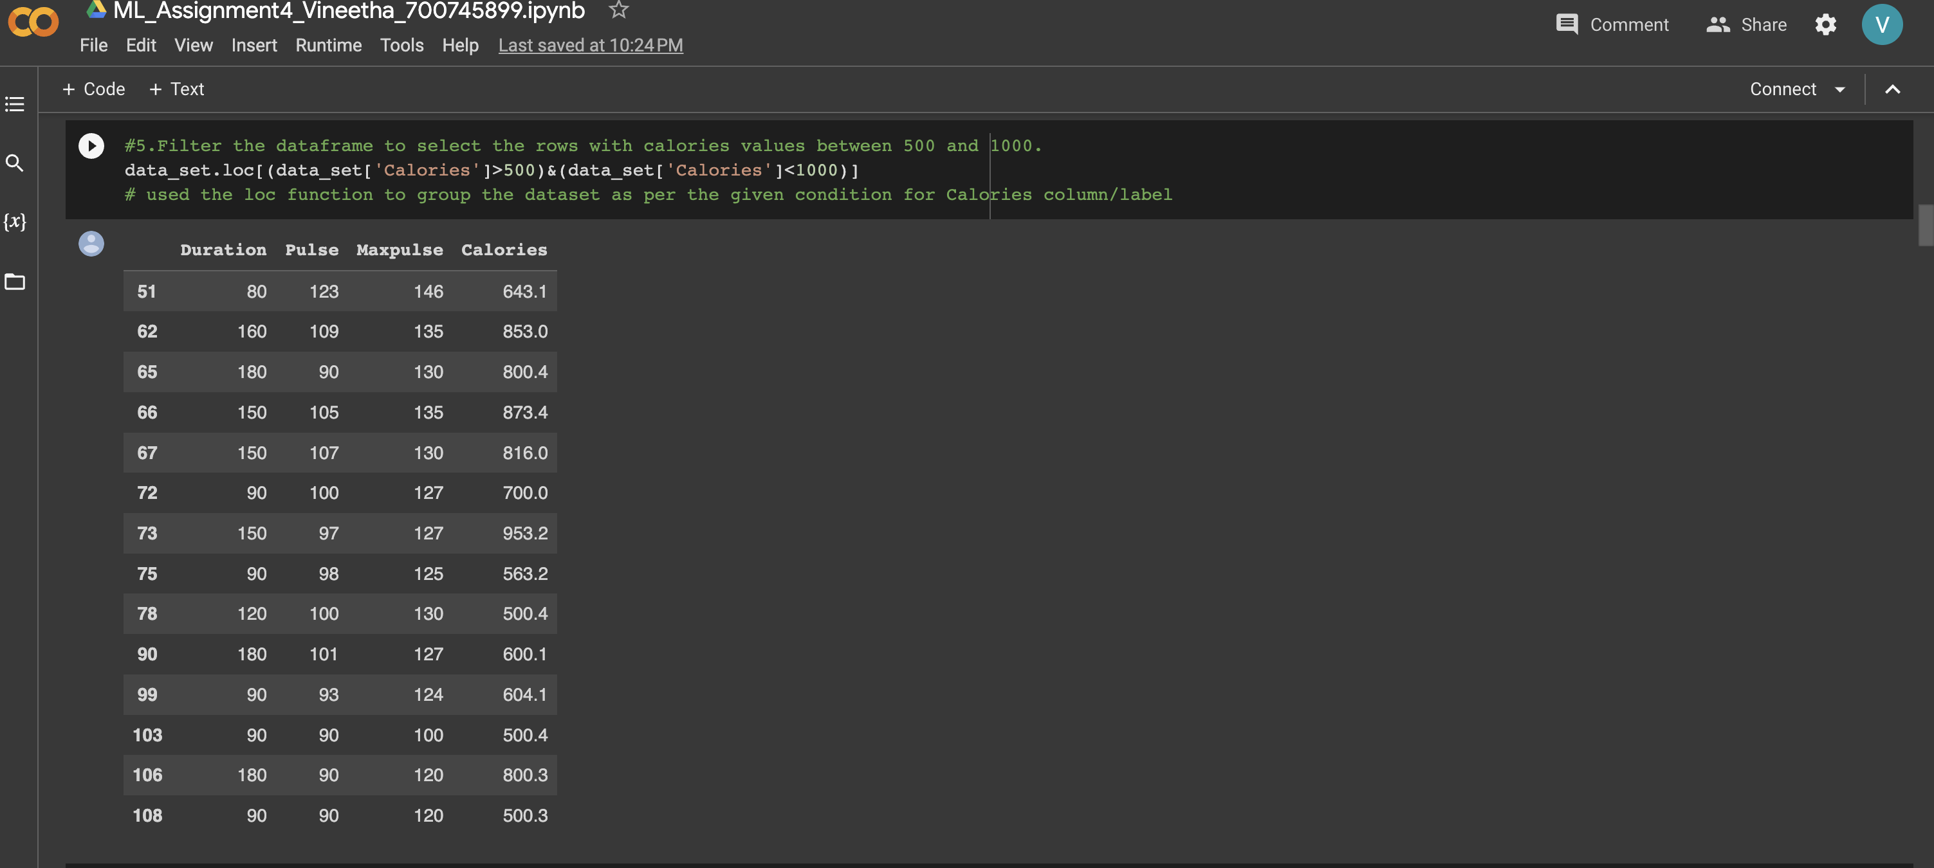

**6. Filter the dataframe to select the rows with calories values > 500 and pulse < 100.**

**Solution 6**:

Here, It is similar to above .loc with a small change in the condition which includes 2 different columns and specific values for each.

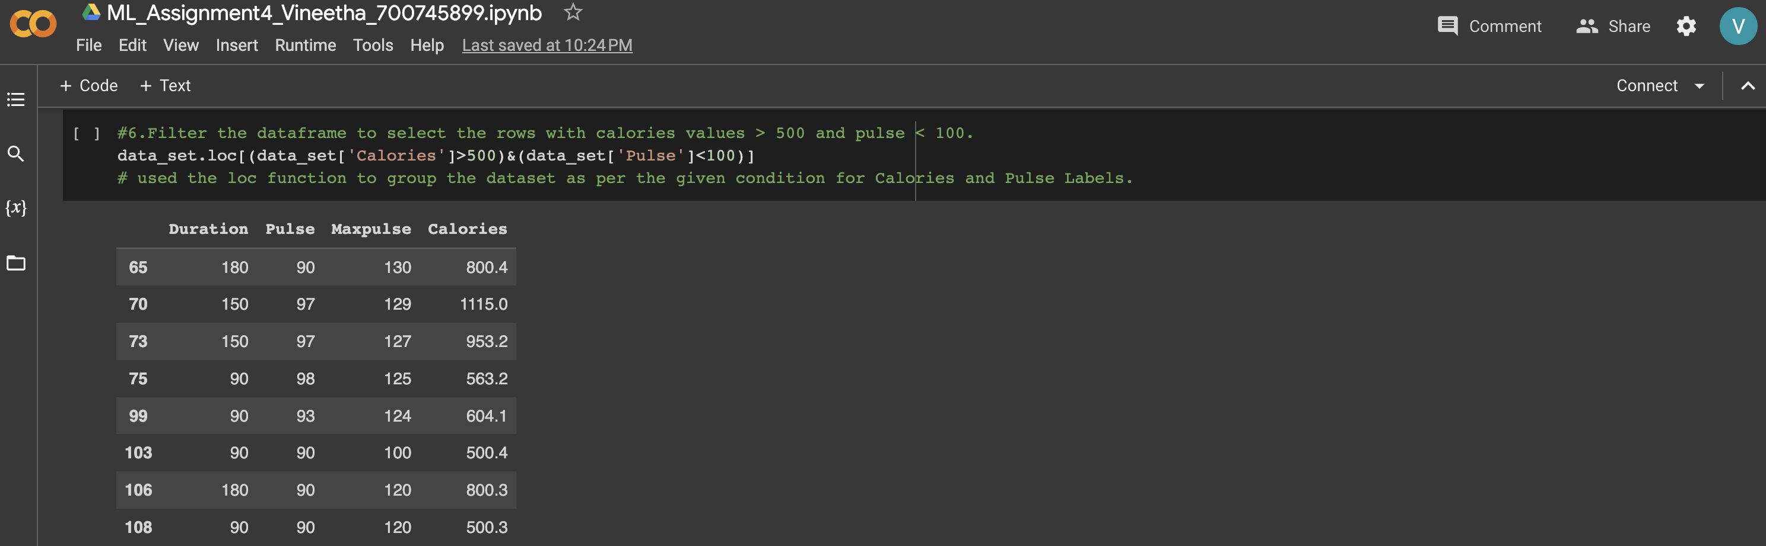

**7. Create a new “df_modified” dataframe that contains all the columns from df except for “Maxpulse”.**

**Solution 7**:

Df_modified is created and initialized with the required columns mentioned inside the dataframe ,i.e., excluded the ‘MaxPulse’ Column.

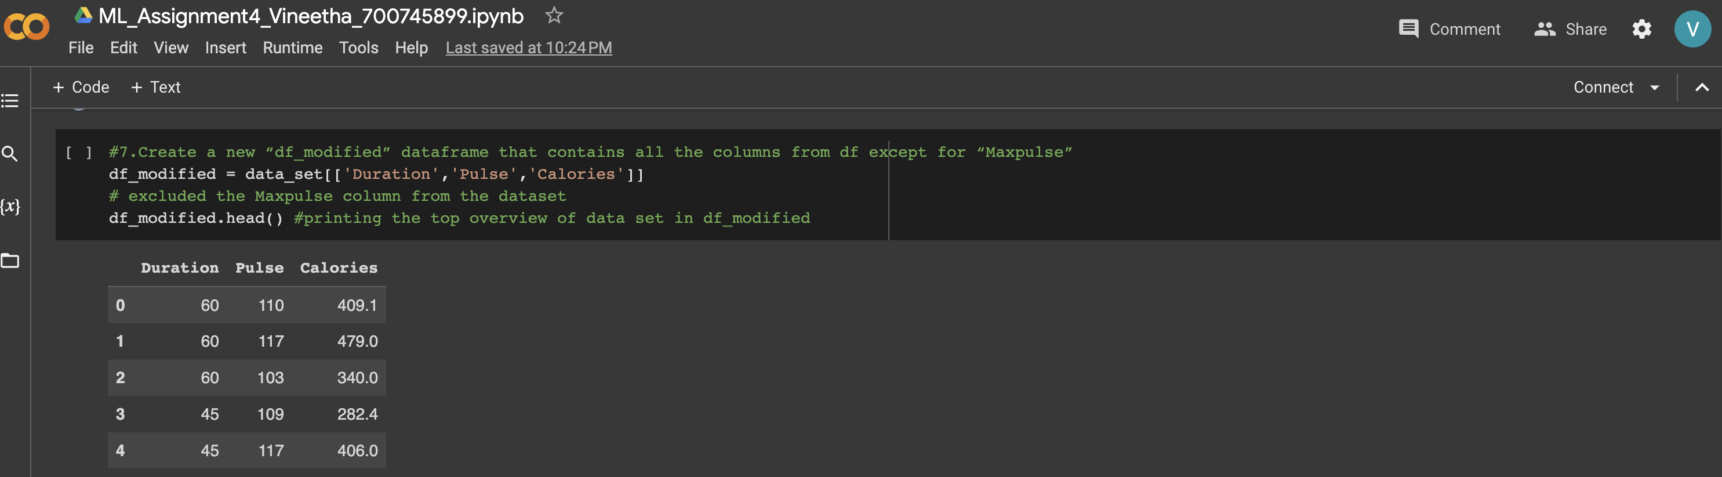

**8. Delete the “Maxpulse” column from the main df dataframe**

**Solution 8**:

Del is the keyword used to specify which dataframe to delete and dataframe[‘MaxPulse’] deletes only the MaxPulse column from the dataframe as shown below.

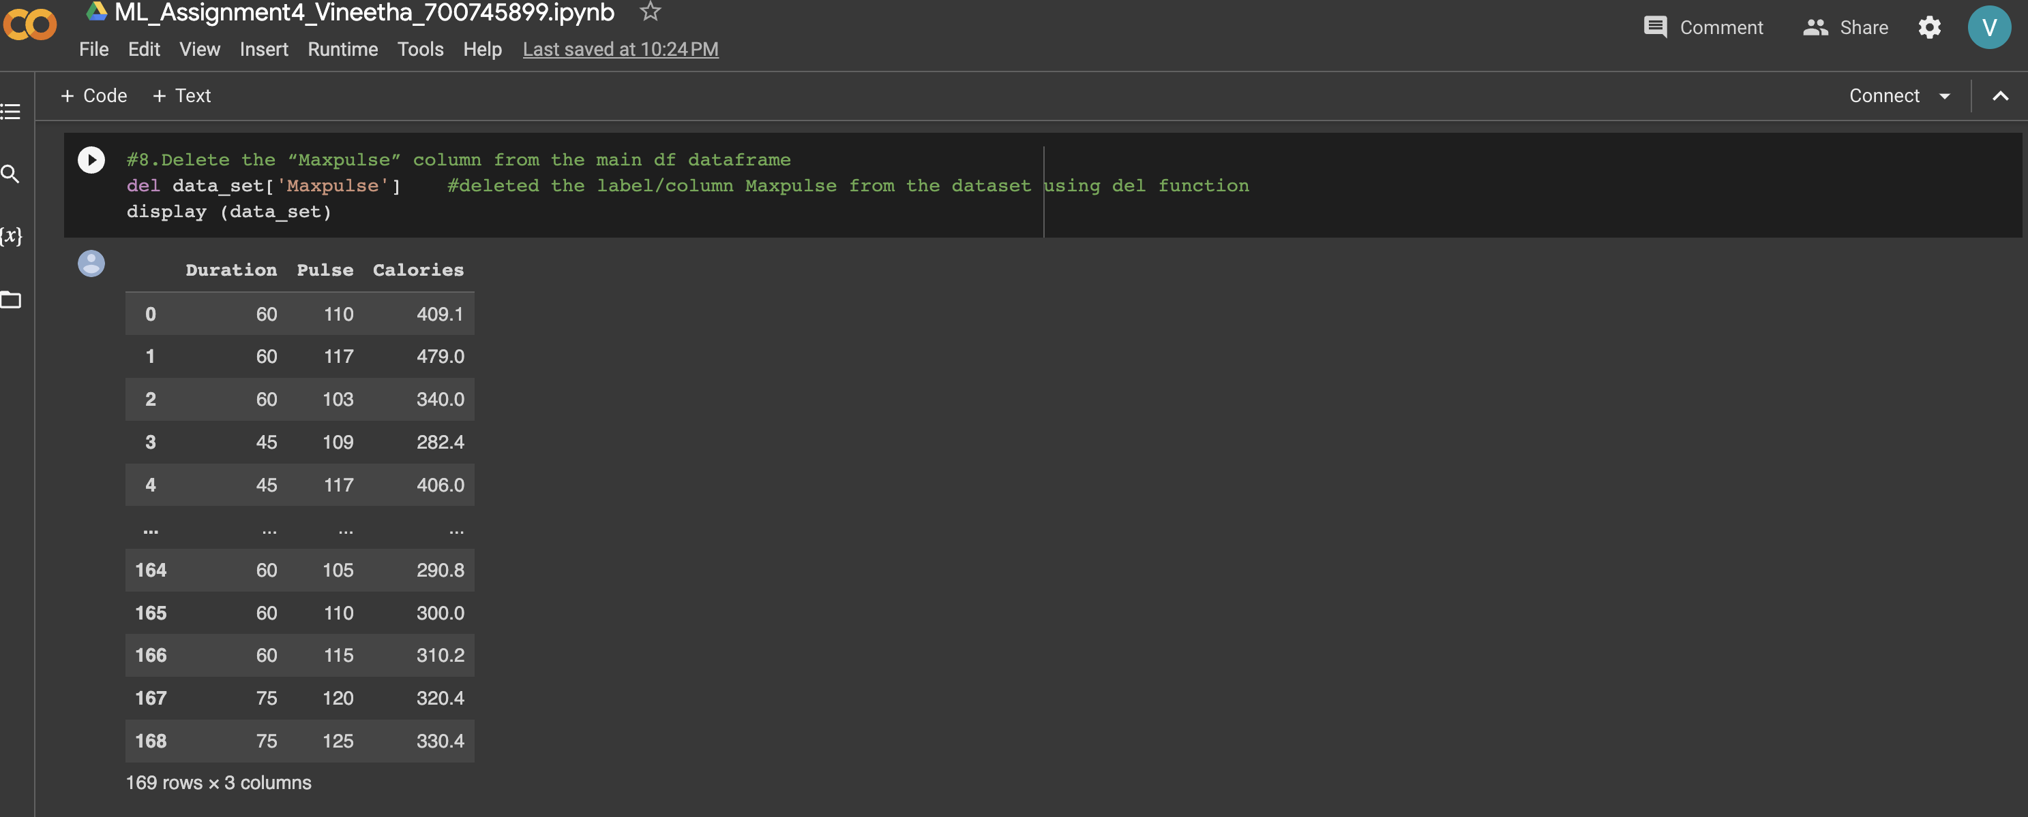

**9. Convert the datatype of Calories column to int datatype.**

**Solution 9**:

.asType is used to convert from one datatype to another.

.dTypes is used to display the datatype of the dataframe

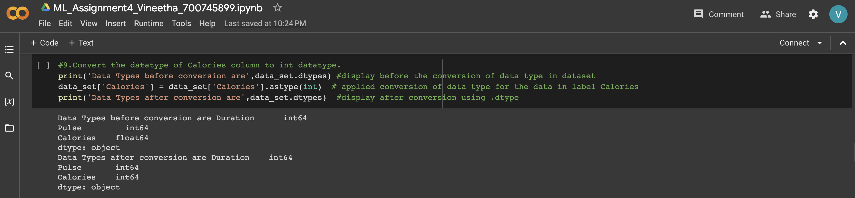

**10. Using pandas create a scatter plot for the two columns (Duration and Calories).**

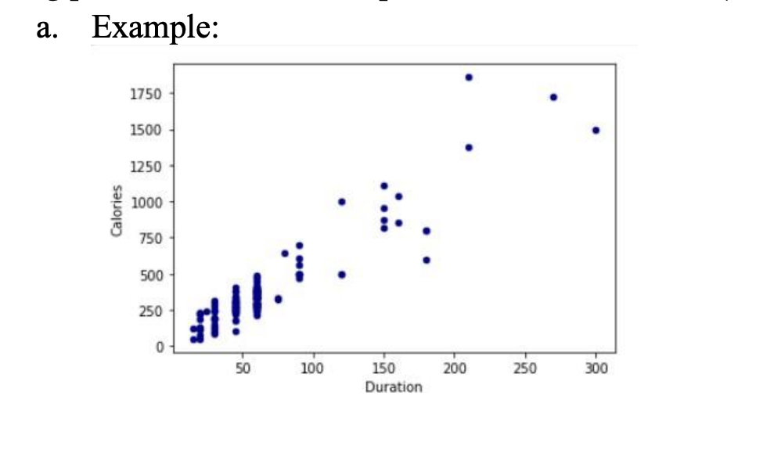

**Solution 10**:

.plot.scatter is used plotting scatter plot between two columns mentioned.(Duration and Calories).

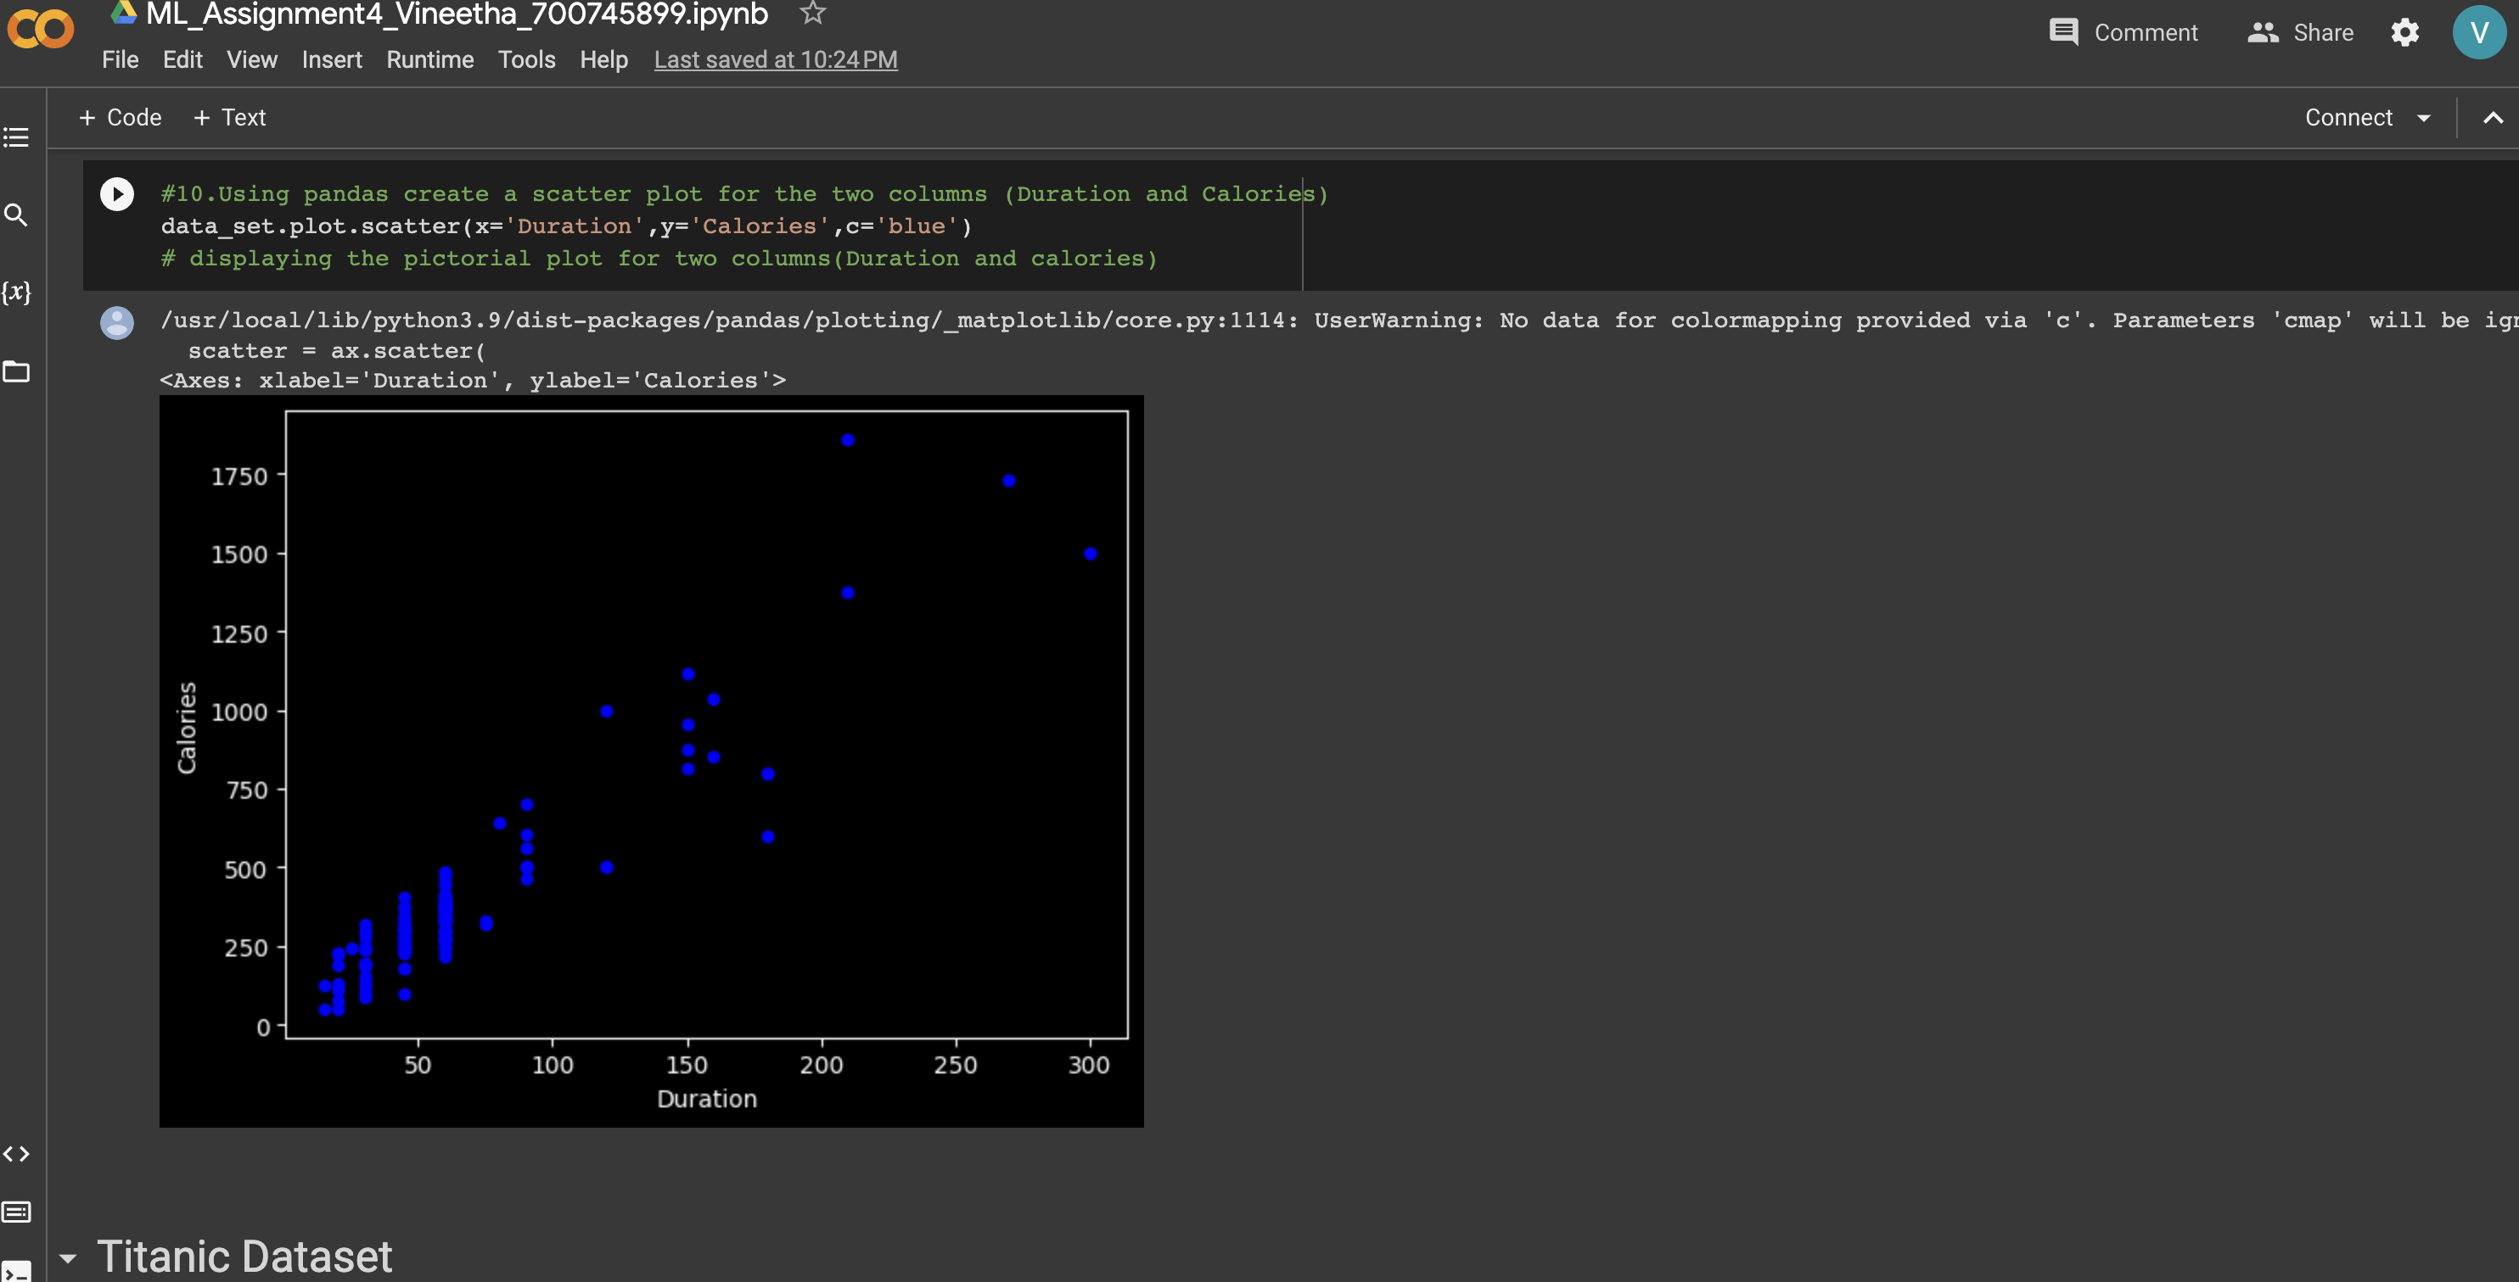

**1. (Titanic Dataset)**

**1. Find the correlation between ‘survived’ (target column) and ‘sex’ column for the Titanic use case inclass.**

**Solution 2.1**:

I have loaded the train.csv and test.csv datasets and then used .corr() for getting the values of correlation between 2 variables.

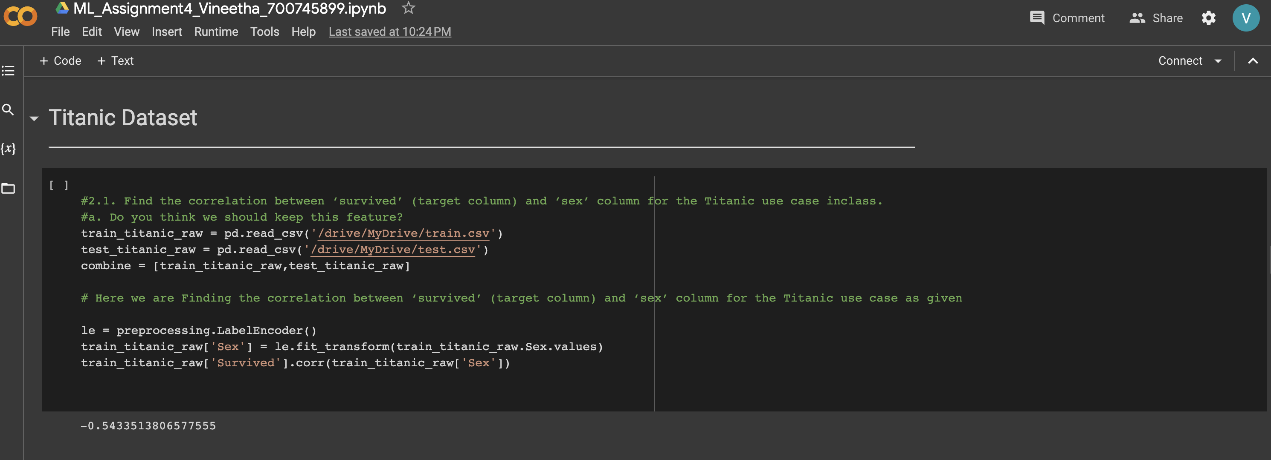

1. **Do you think we should keep this feature?**

when we see in the output of correlation matrix for train dataset, -0.54 is much better value compared to all other correlations with other columns, as Survived is our target column and it is more correlated with Sex,

Therefore, It is necessary to keep this feature for our further analysis.

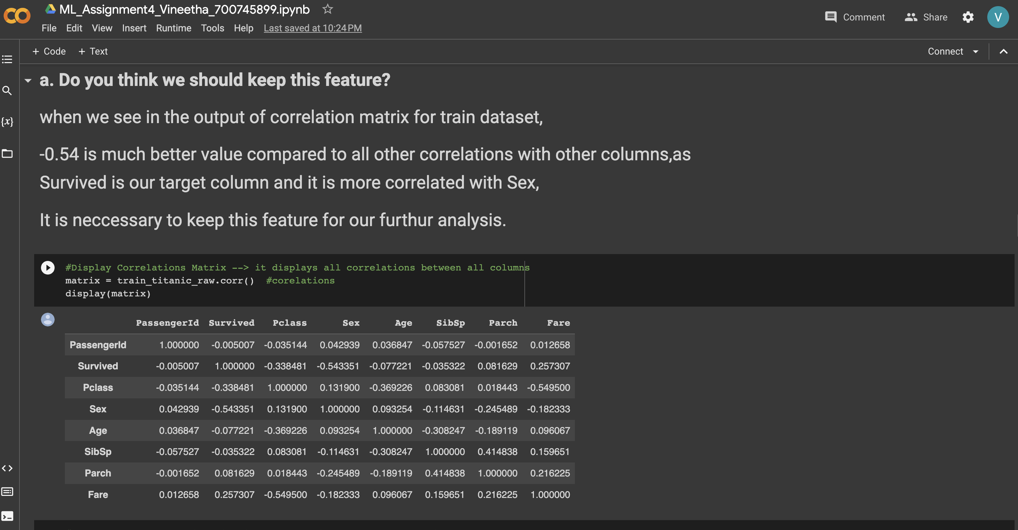

**2. Do at least two visualizations to describe or show correlations.**

I have plotted correlation matrix, heatmap as well as regression plot as shown in the below screenshots.

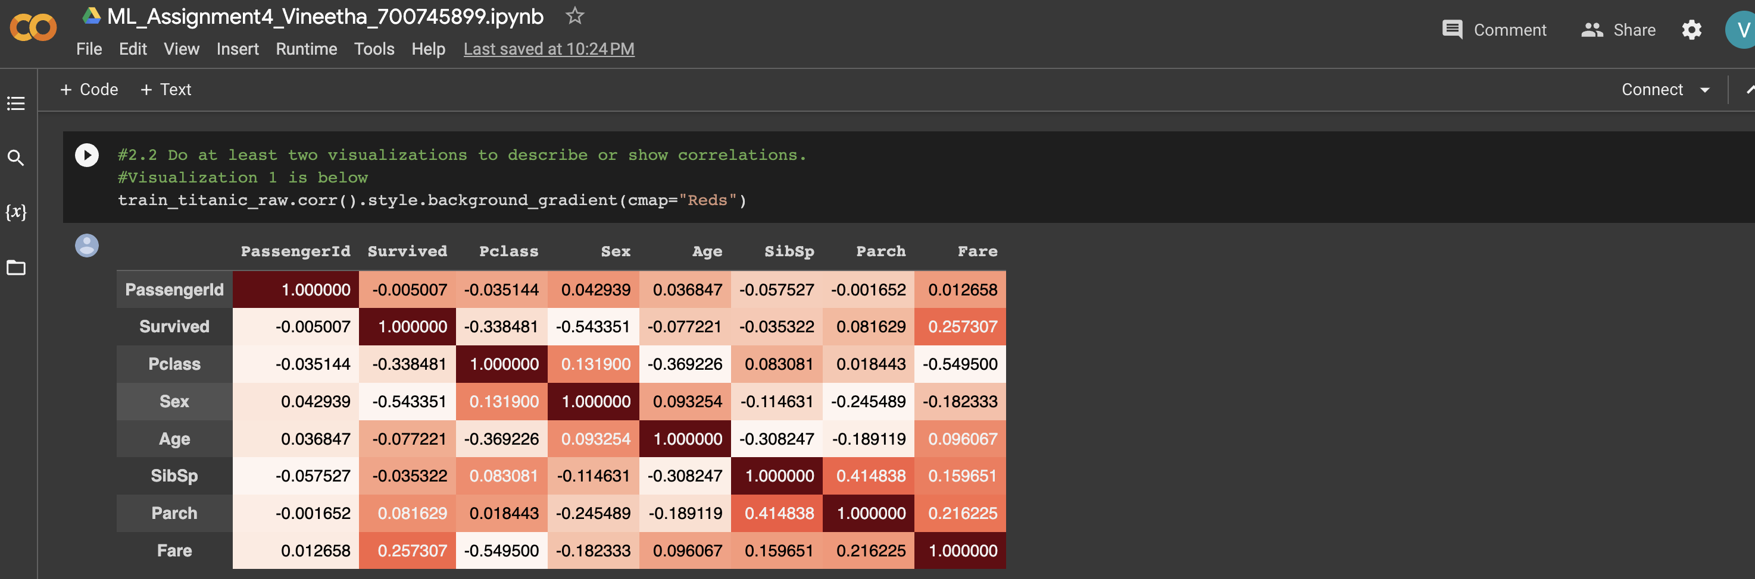

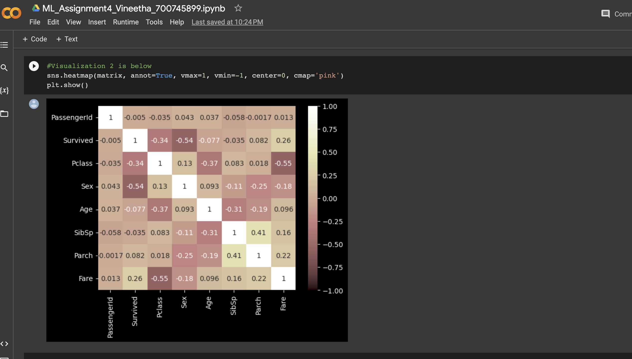

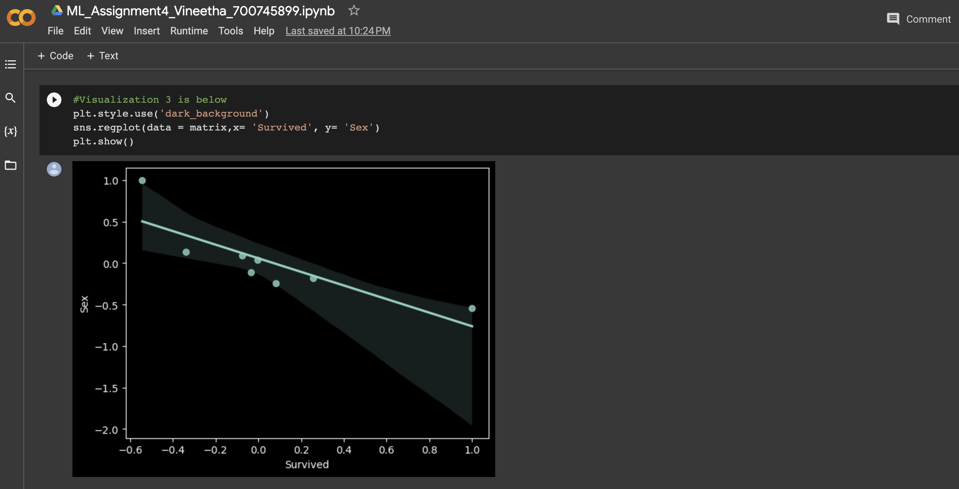

**3. Implement Naïve Bayes method using scikit-learn library and report the accuracy.**

After importing the train and test data. I have declared the features and target variable list into two variables.

Then two categorical variables Sex and Embarked are converted into numerical.

Now Dataset is tested for null values and they are removed according to the requirement, few are replaces with mean, some with median and others with max values.

After data cleaning, the refines dataframe is now given as input to the classifier.

Here we used naïve bayes method of classification (gaussianNB()).

Classification_report, Accuracy and performance are measured and displayed as shown below.

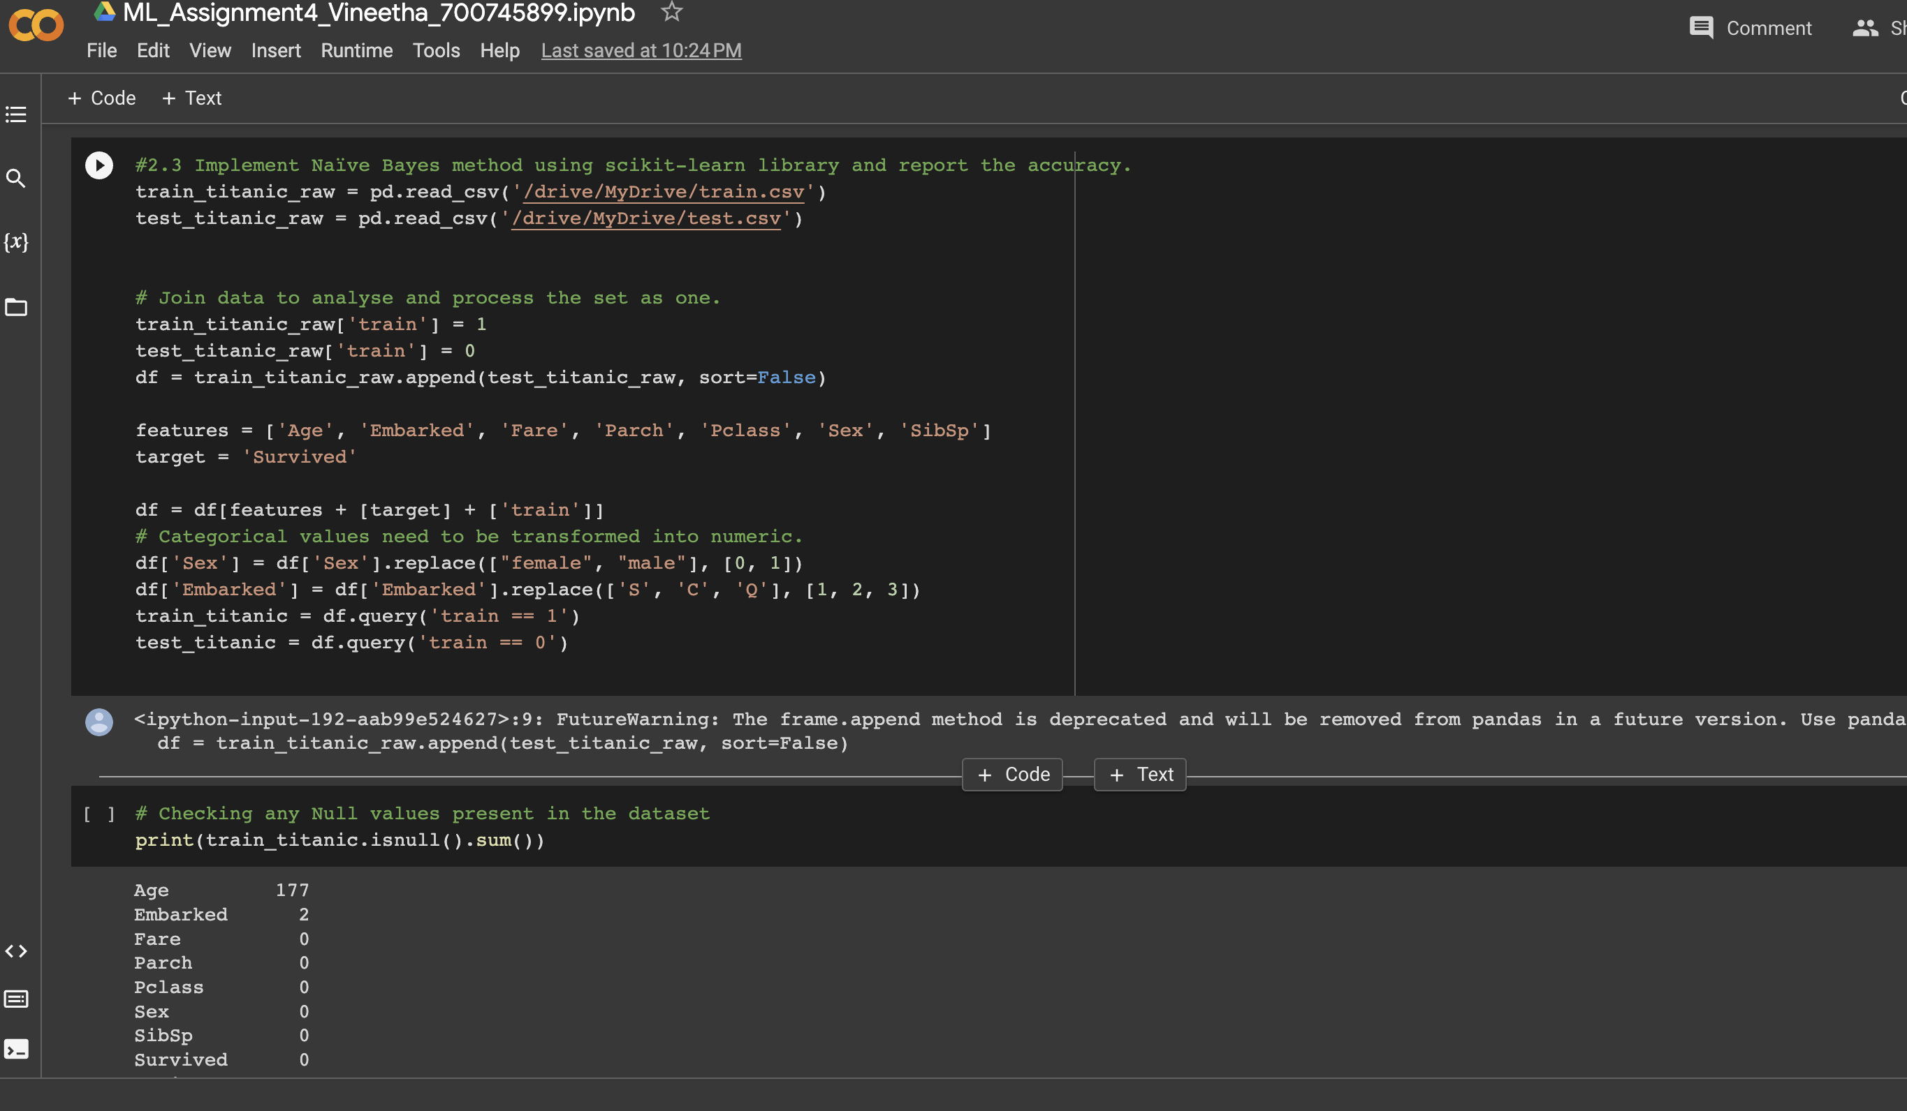

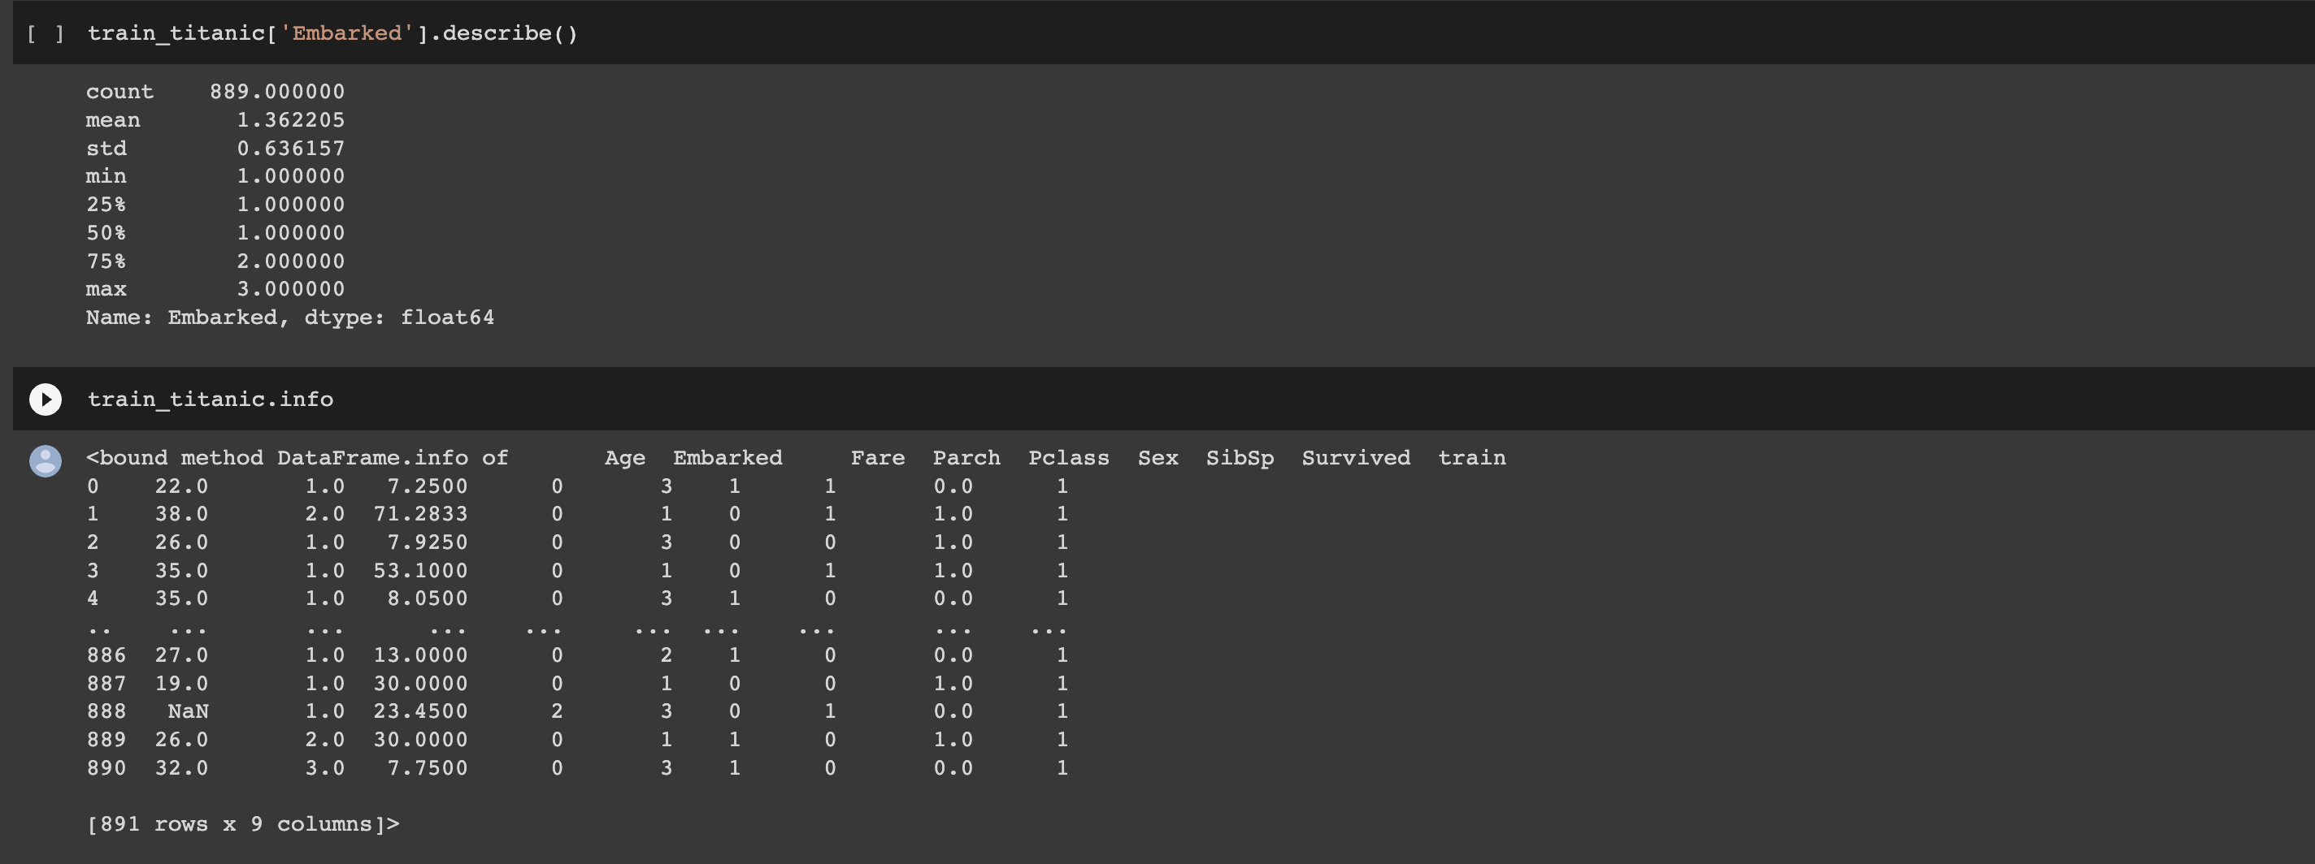

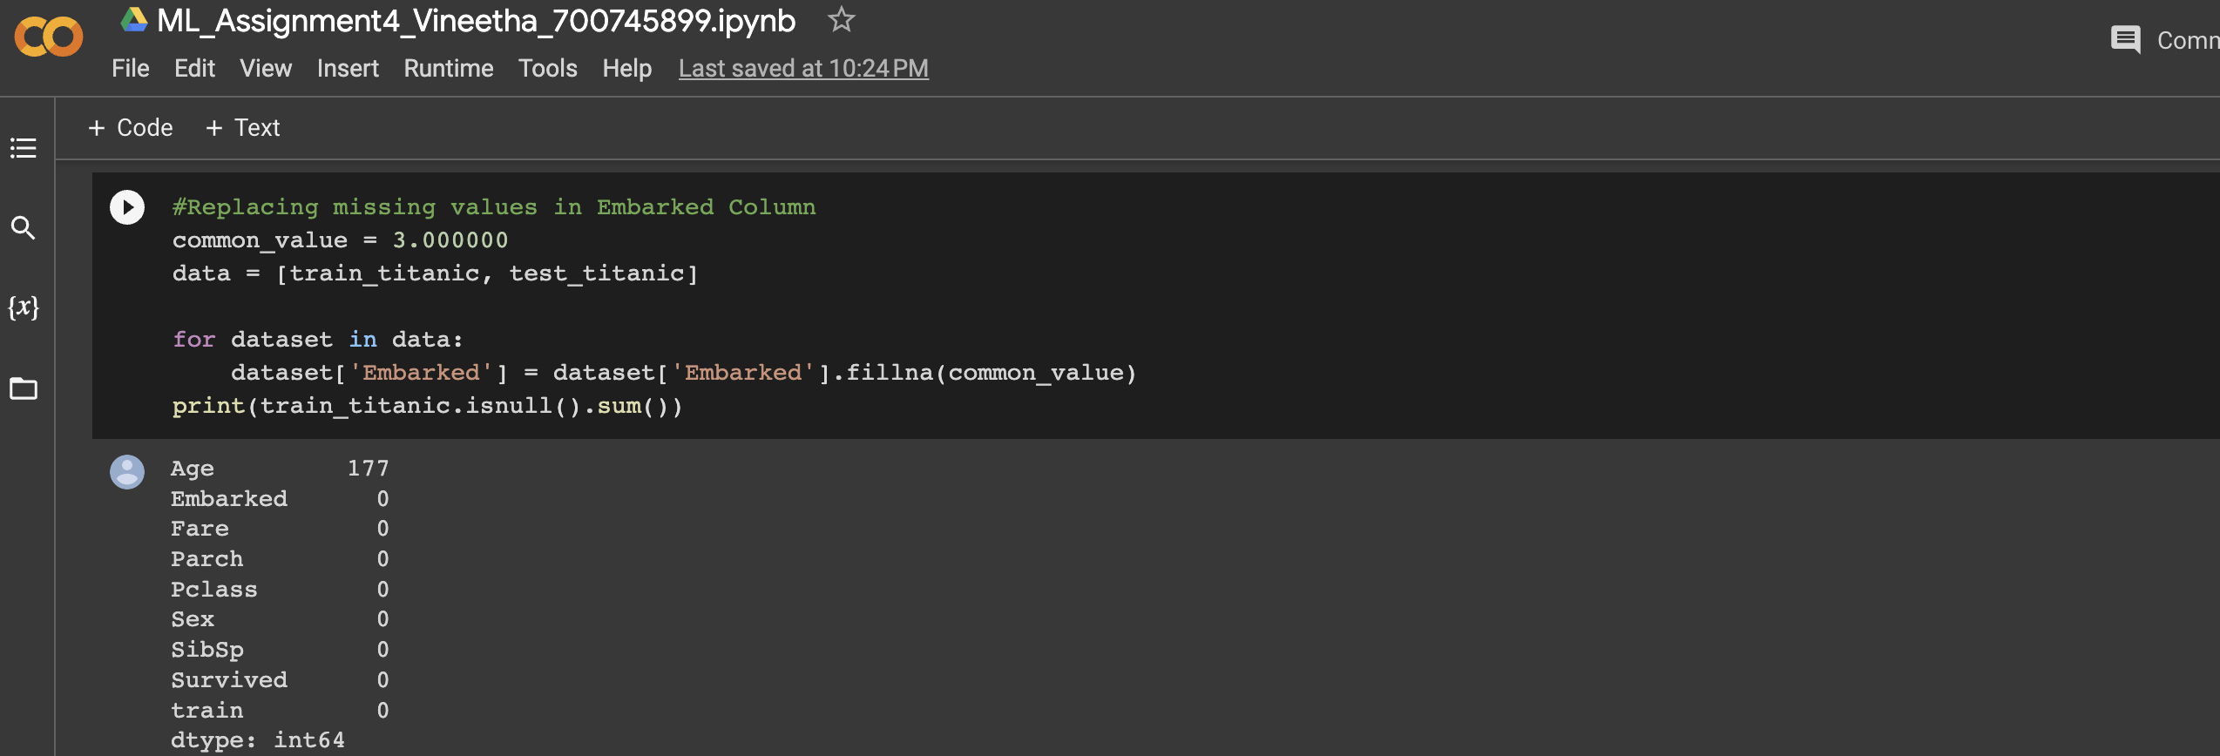

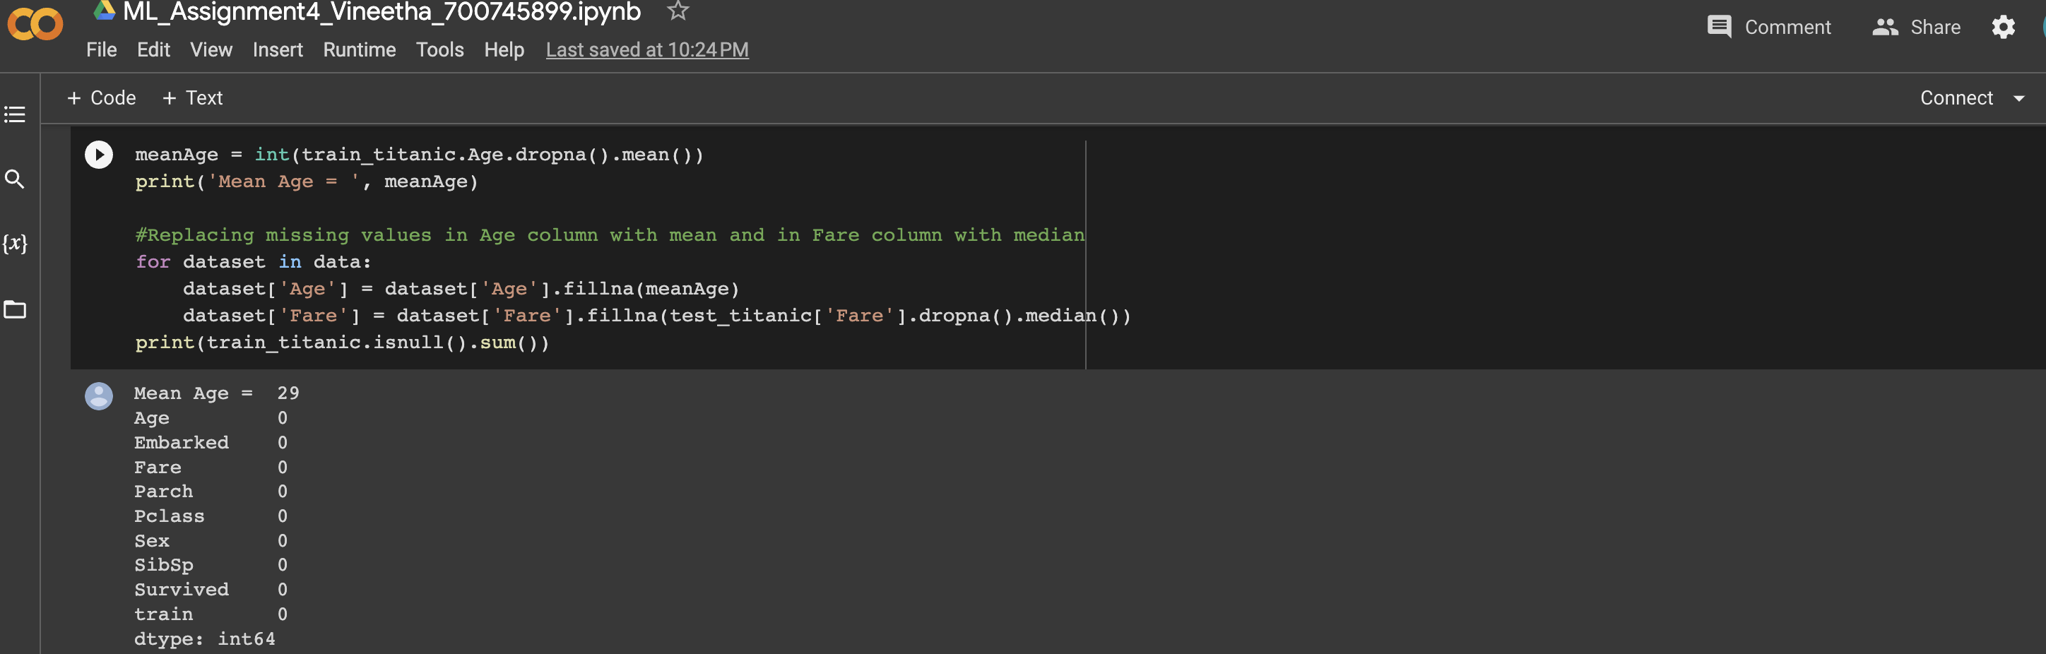

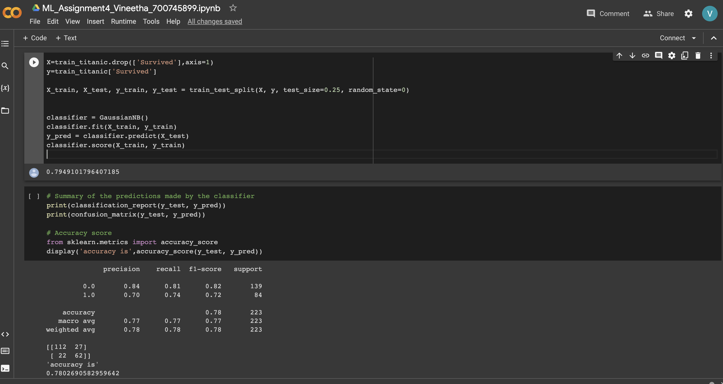

**2. (Glass Dataset)**

**1. Implement Naïve Bayes method using scikit-learn library.**

**a. Use the glass dataset available in Link also provided in your assignment.**

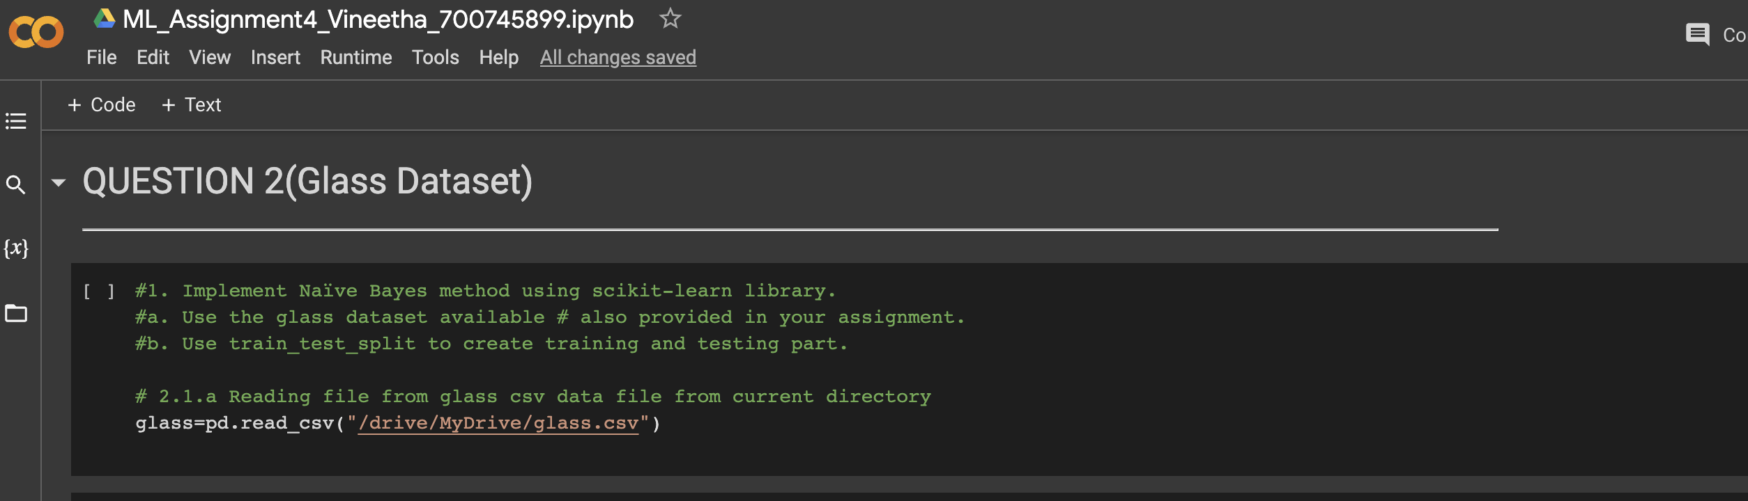

1. **Use train_test_split to create training and testing part.**
2. **Evaluate the model on testing part using score and classification_report(y_true, y_pred)**

After importing the train and test data. I have declared the features and target variable list into two variables.

Here dataset is divided into test and train spli using train_test_split into 20 and 80 resp.

Here we used naïve bayes method of classification (gaussianNB()).

Classification_report, Accuracy and performance are measured and displayed as shown below.

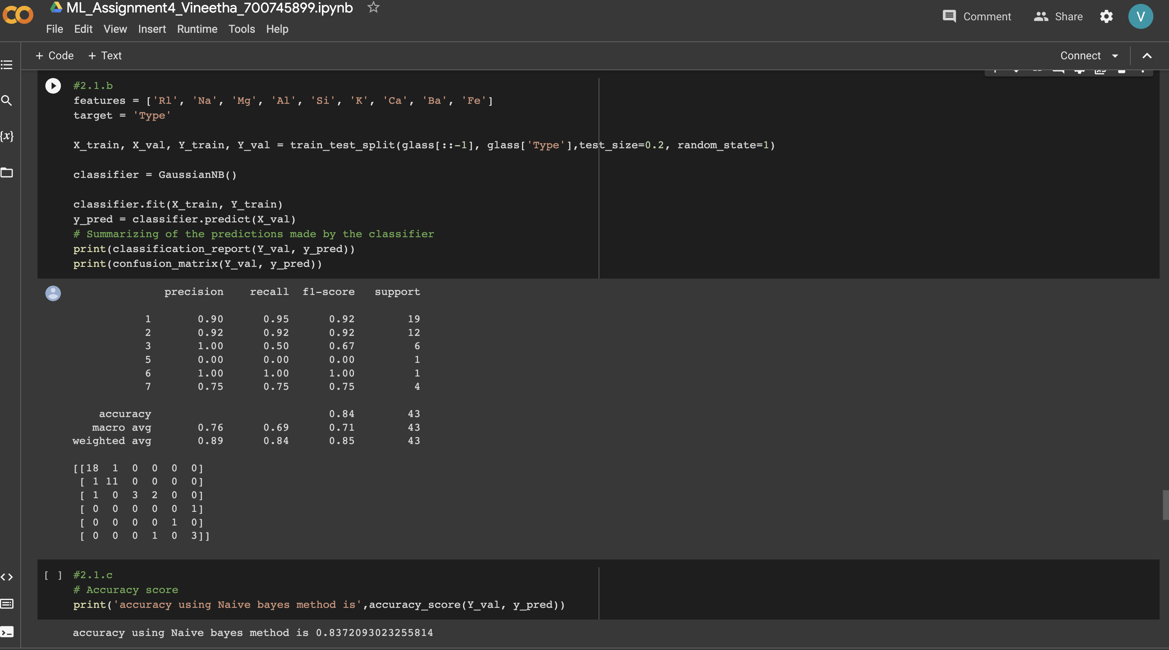

**2. Implement linear SVM method using scikit library**

**a. Use the glass dataset available in Link also provided in your assignment.**

**b. Use train_test_split to create training and testing part.**

**c. Evaluate the model on testing part using score and classification_report(y_true, y_pred)**

After importing the train and test data. I have declared the features and target variable list into two variables.

Then two categorical variables Sex and Embarked are converted into numerical.

Now Dataset is tested for null values and they are removed according to the requirement, few are replaces with mean, some with median and others with max values.

After data cleaning, the refines dataframe is now given as input to the classifier.

Here we used Linear SVM method of classification (LinearSVC()).

Classification_report, Accuracy and performance are measured and displayed as shown below.

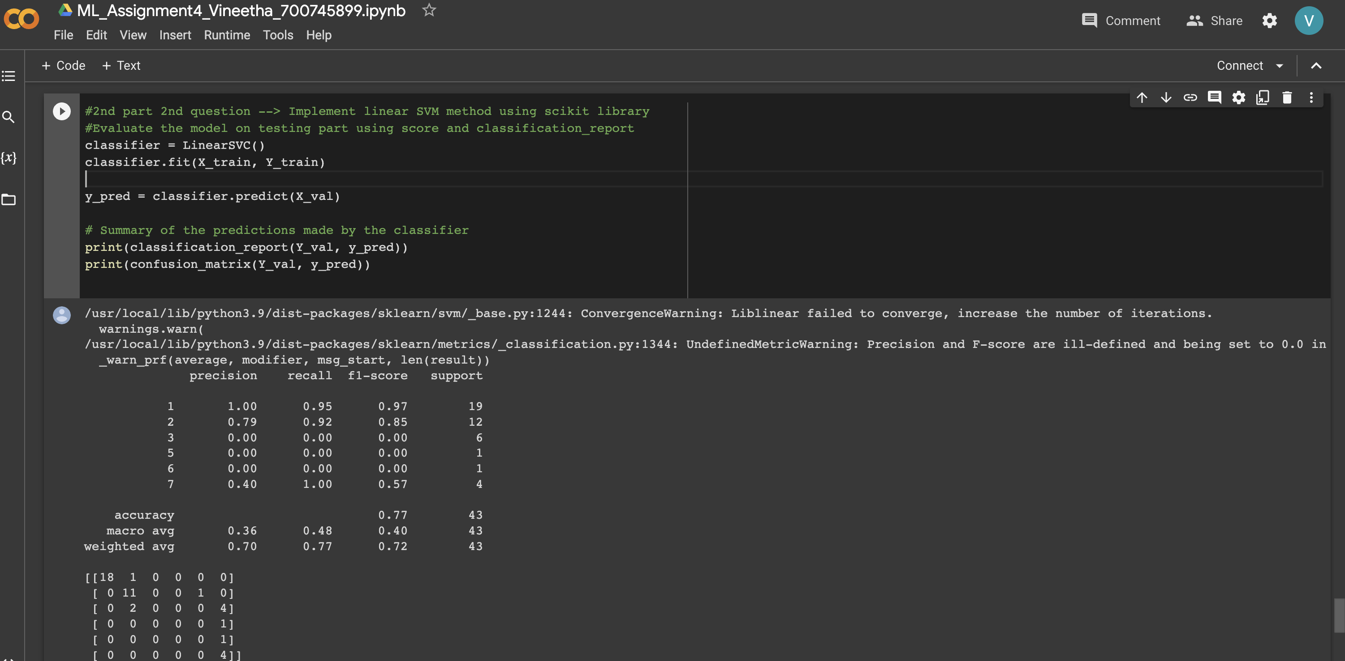

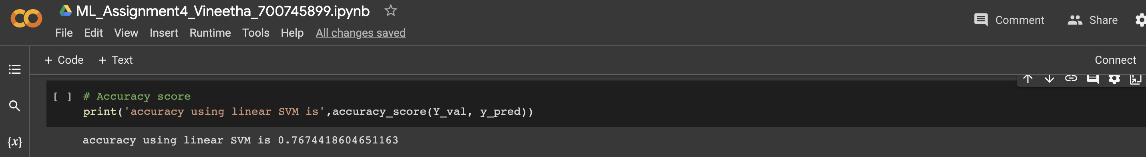

**Do at least two visualizations to describe or show correlations in the Glass Dataset.**

I have plotted correlation matrix, heatmap as shown in the below screenshots.

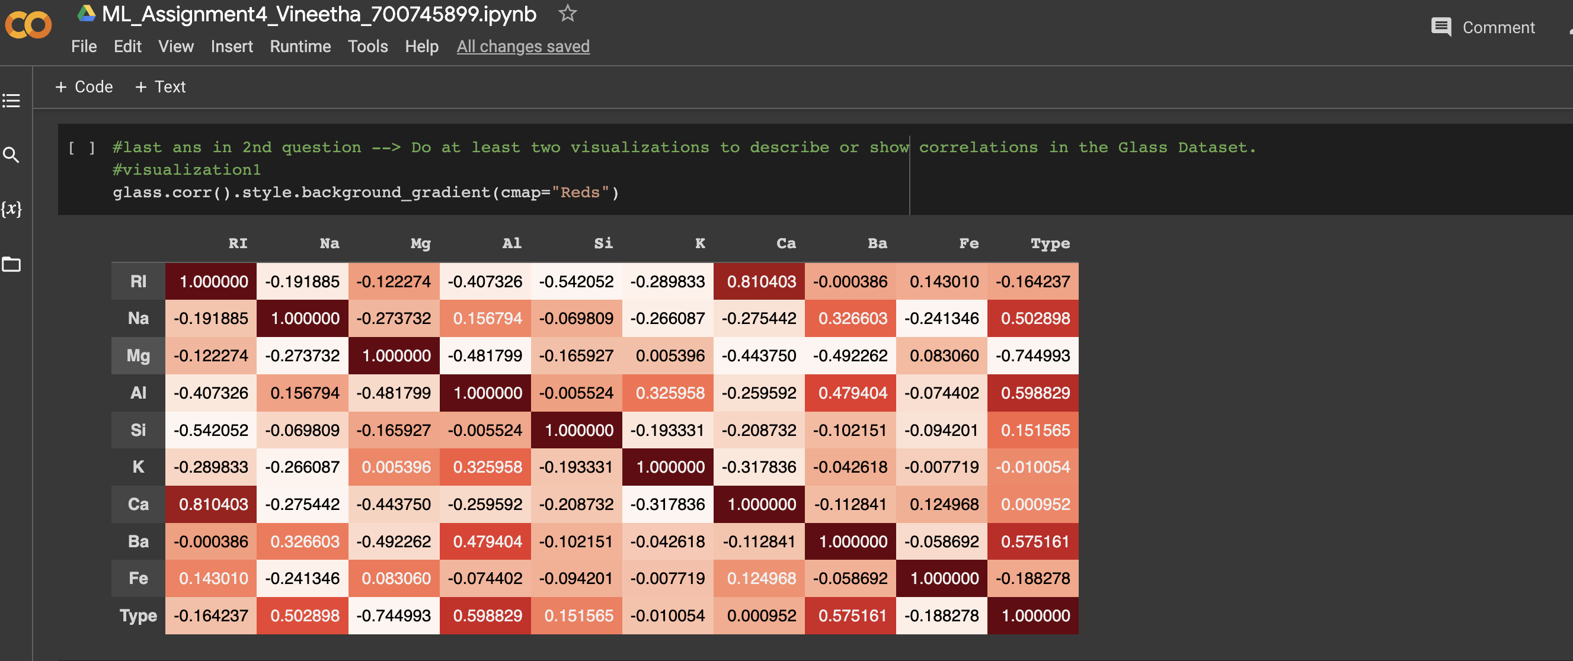

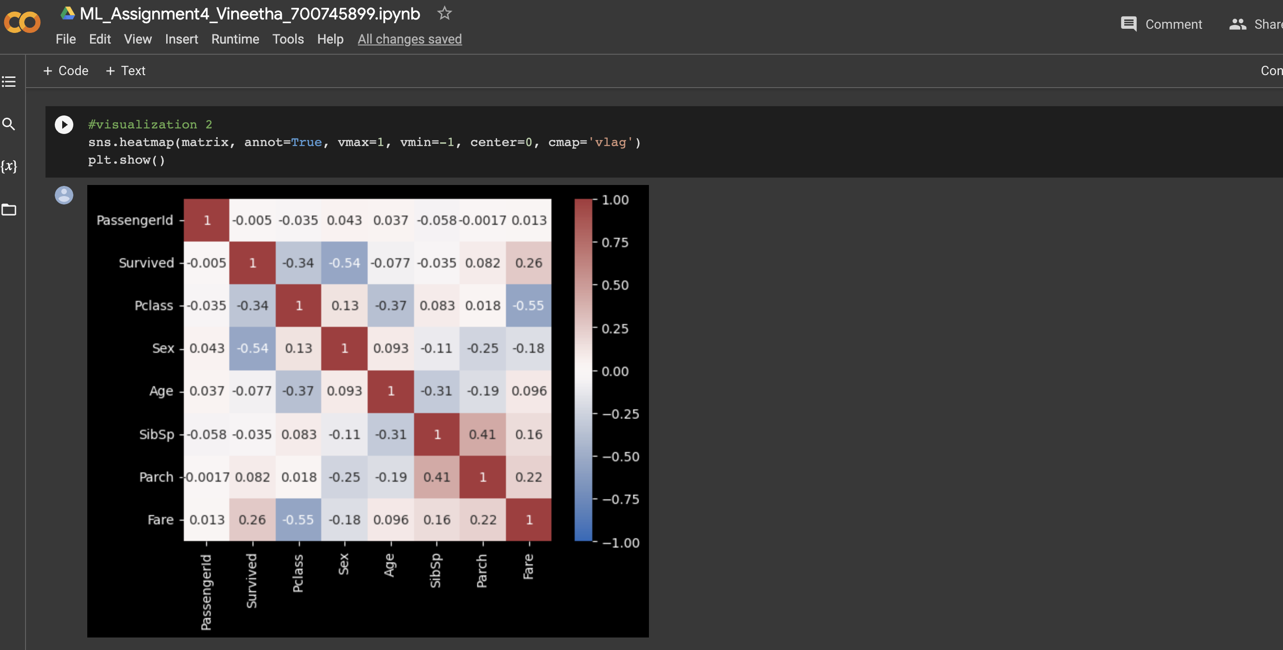

**Which algorithm you got better accuracy? Can you justify why?**

Naive bayes accuracy is greater than the accuracy that we got from linearSVM.This may be due to the following reasons:

1)We know that Naive Bayes assumes all the features are conditionally independent for the given dataset, this can be conditionally best with few datasets. Whereas,LinearSVM does not make any assumptions about the independence or correlation between the features, and it tries to find the optimal hyperplane that separates the data points. If the features are actually conditionally independent given the class, Naive Bayes can achieve better accuracy by exploiting this structure in the data.

2) Naive Bayes can handle categorical and continuous data, as well as missing values, more easily than LinearSVM. The glass dataset contains a mix of categorical and continuous features, naive Bayes will be able to handle these cases more effectively than LinearSVM.

